**IOT LAB: 39**

**TASK 1: CREATE BAR GRAPH USING MATPLOTLIB**

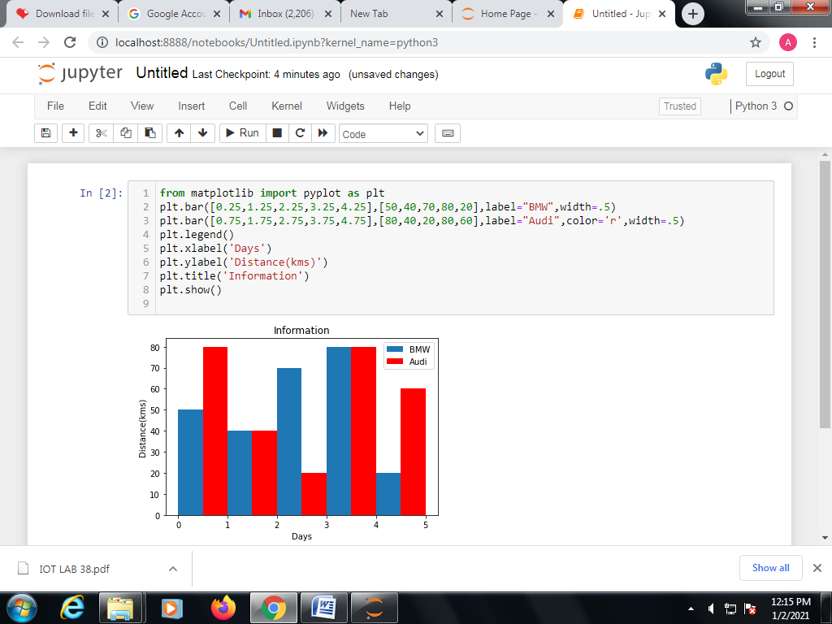

**OUTPUT:**



**TASK 2: USE SEABORN LIBRARY**

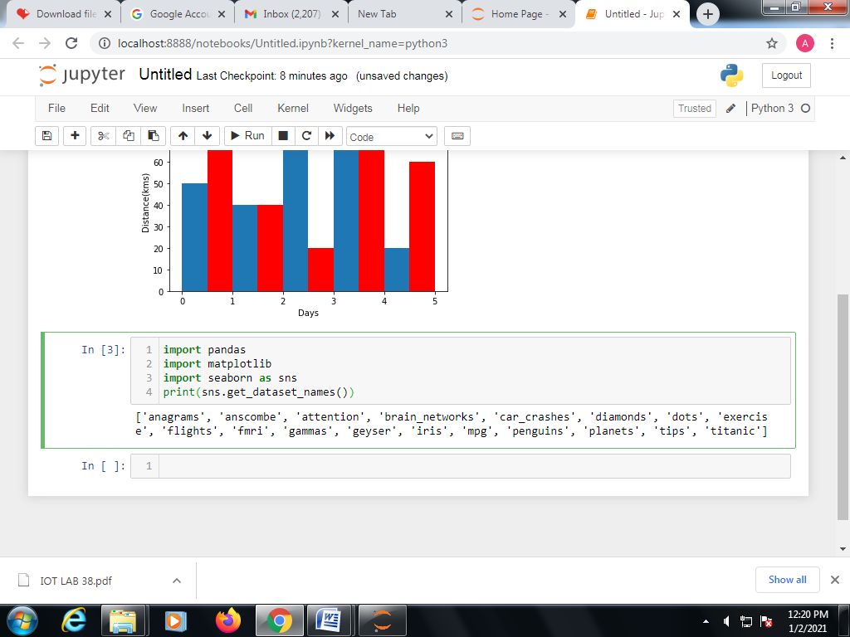

**OUTPUT:**



**TASK 3: ACCESS BUILTIN DATASETS OF SEABORN**

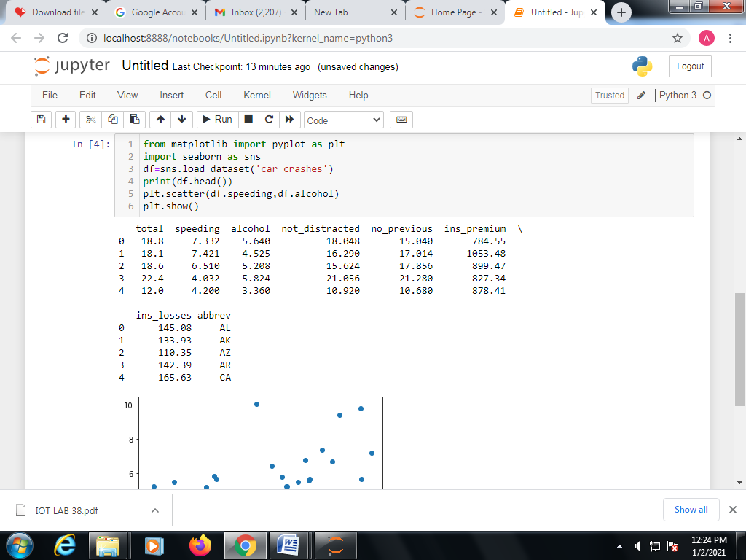

**OUTPUT:**

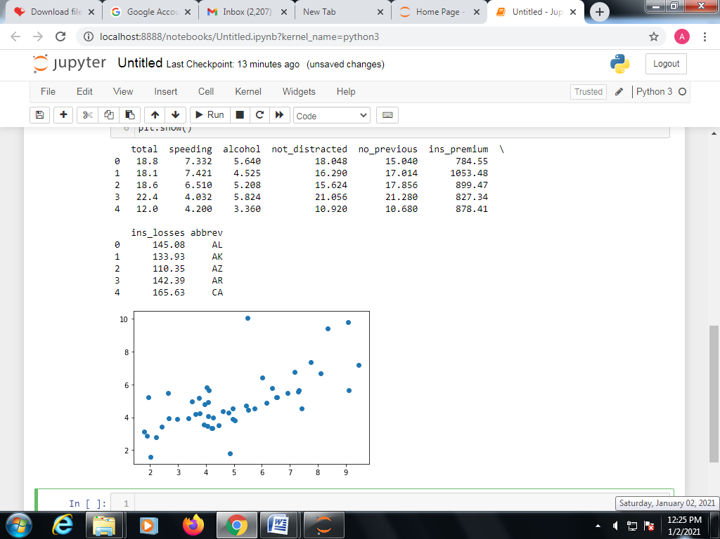

**TASK 4: LOAD DATA SET AND CREATE DATA SET USING SEABORN**

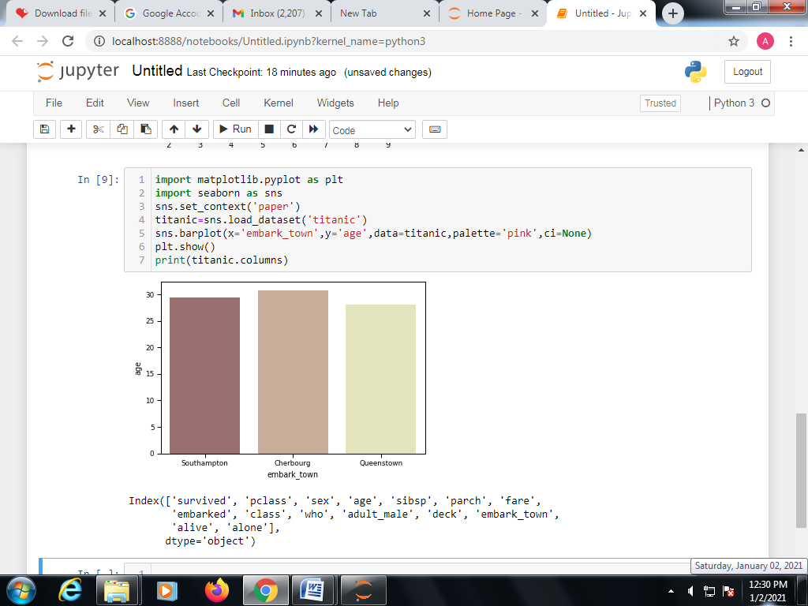

**OUTPUT:**

